**SOFTWARE REQUIREMENT SPECIFICATION (SRS)**

**FOR FOOD-DELIVERY WEBSITE**

**NAME:** MONISH.G

**COLLEGE NAME:** RAJALAKSHMI INSTITIUTE OF TECHNOLOGY

**DEPARTMENT:**COMPUTER AND COMMUNICATION ENGINEERING

**COLLEGE CODE:** 2113

**BATCH:** A52

**Introduction:**

Food is one of the essential things in our daily life. In our daily life we experience many type peoples, cultures and their food varities. For Atleast one time in our life we think of tasting thier foods with them

**Objective:**

To overcome the above situation we can build a food delivery website.The Food Delivery Website is an online platform that provides customers with the ability to order food from local restaurants and high-class multi cuisine restaurants and have it delivered to their doorstep. This document defines the requirements for the system, including functional, non-functional, and interface requirements

**Scope:**

Convenience: Online food ordering is incredibly convenient, as customers can order food from the comfort of their homes or workplaces, without having to physically visit a restaurant or speak to a customer service representative.

Time-saving: Online ordering saves time, as customers can quickly browse menus, place orders, and make payments with just a few clicks or taps.

Choice: Online food ordering provides customers with a wide range of options, as they can browse multiple restaurants and menus at once, compare prices and cuisines, and choose the best option that suits their tastes and preferences.

Customization: Online ordering allows customers to customize their orders, add special requests, and view nutritional information, making it easier for them to make informed decisions about their food choices.

Transparency: Online food ordering platforms provide transparency in terms of pricing, delivery times, and order tracking, giving customers the information they need to plan their meals and manage their schedules.

**Overall Description:**

A food delivery website provides customers with a convenient and easy way to order food, while providing restaurants with a powerful platform for managing their businesses and reaching new customers.

**Software Requirement:**

**Front-end:**

* Android developer Tool
* VS code editor
* Javascript ,html, css
* Node js, React js

**Back-end:**

* Django

**Hardware Requirement:**

* Android version 2.3 ginger bread(minimum, android user’s)
* 4GB ram
* 1.2 GHz processor
* Intel i5 Windows 7/8/8.1/10/11

**Functional Requirements:**

**User Management**

a. Registration and Login: Users should be able to create and log into their accounts. Users should be able to retrieve forgotten passwords.

b. Profile Management: Users should be able to edit their profiles, update their personal information, and manage their delivery addresses.

**Restaurant Management**

a. Menu Management: Restaurants should be able to manage their menus, including adding and removing items, changing prices, and modifying descriptions.

b. Order Management: Restaurants should be able to receive and manage orders placed by customers.

c. Communication: Restaurants should be able to communicate with customers regarding orders and provide updates on delivery times.

**Order Management**

a. Placing Orders: Customers should be able to browse restaurants, view menus, and place orders.

b. Payment: Customers should be able to make payments online using credit cards, debit cards, or other payment methods.

c. Order Tracking: Customers should be able to track the status of their orders, receive delivery updates, and view delivery locations on a map.

**Search and Filtering**

a. Search: Customers should be able to search for restaurants based on location, cuisine type, and other criteria.

b. Filtering: Customers should be able to filter restaurant search results based on rating, price range, and other criteria.

**Non-Functional Requirements:**

a. Performance: The system should be able to handle a high volume of concurrent users and orders without slowdowns or crashes.

b. Security: The system should provide secure transactions and protect user data from unauthorized access.

c. Usability: The system should be user-friendly and intuitive, with clear navigation and easy-to-use interfaces.

d. Reliability: The system should be reliable and available for use 24/7.

**Interface Requirements:**

1. User Interface: The website should have an intuitive and user-friendly interface that is easy to navigate.
2. Mobile Responsiveness: The website should be responsive and accessible on mobile devices.
3. API Integration: The system should be able to integrate with third-party APIs for payment processing, order tracking, and other functionalities.

**Flow Diagram:**

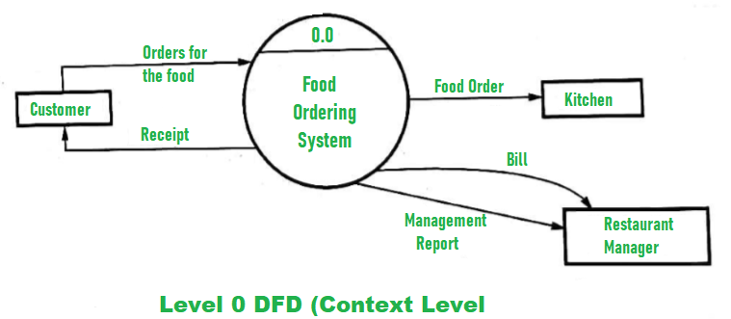

**Usecase Diagram:**

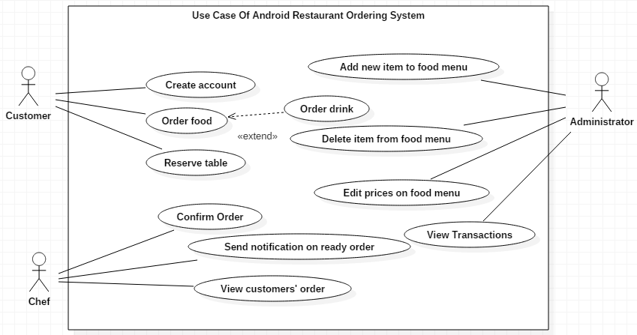

**Class Diagram:**

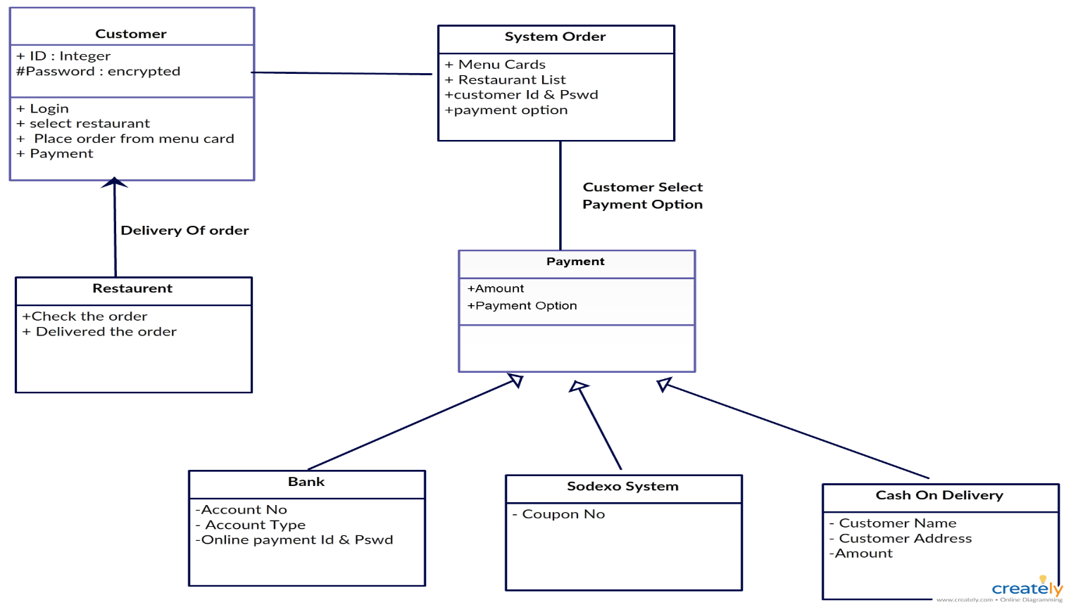

**Sequence Diagram:**

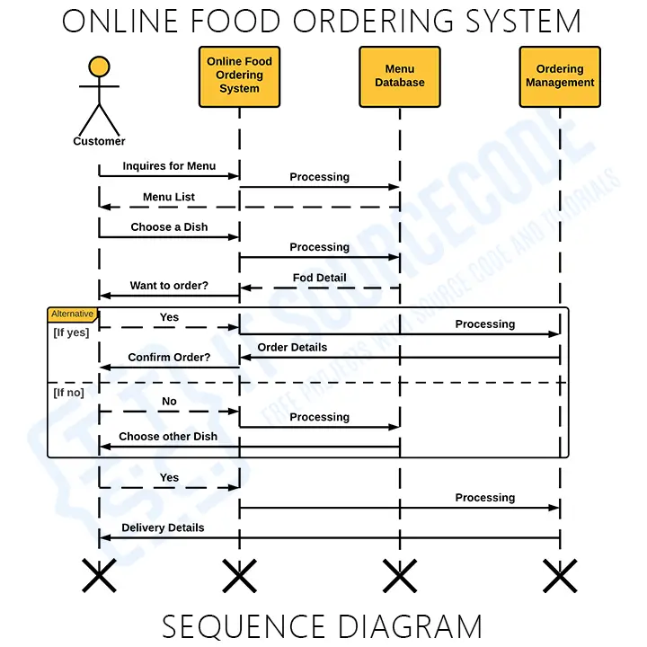

**Activity Diagram:**

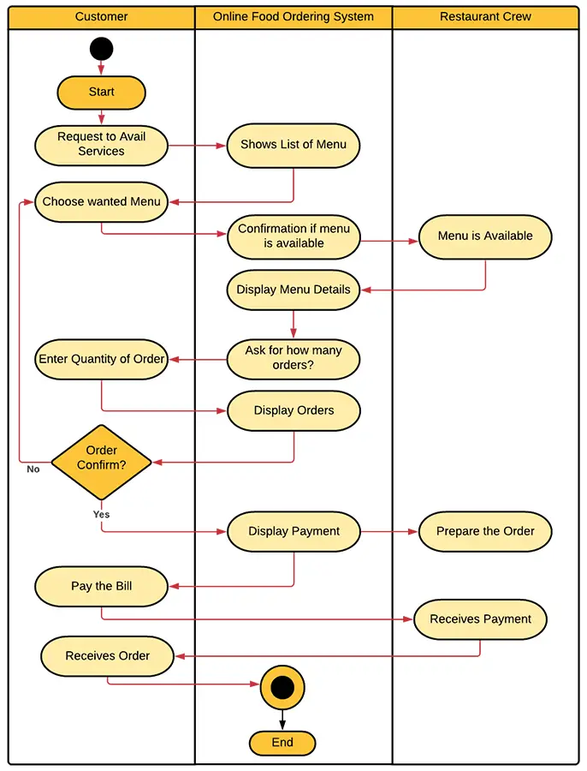

**ER Diagram:**

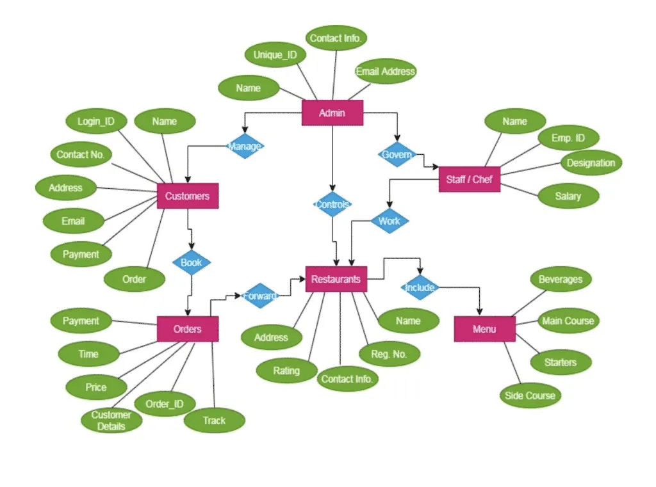

**Assumptions and Dependencies:**

The following third party applications for the development of the project:

• Android Studio (for development of android based applications)

• Netbeans

• Photoshop (for editing layouts, icons, buttons, etc)